CA06-RU
@startuml

title "USE CASE : REGISTER USER (CA06-RU)"

note "See Use Case CA03-LI" as LI

actor IT <<user>> as IT
Client <<application>> as CLI
Server <<application>> as SER

(Register User) as REG
(Verify Username Uniqueness) as VERIFY
(Store New User) as STORE

IT .> LI

IT --> CLI : User logs into Client
CLI --> REG : User selects\n"Register User"\nand inputs credentials
REG --> SER : Send user data
SER --> VERIFY : Check credentials
VERIFY --> STORE : Store user
STORE --> SER
STORE .> CLI : Return to console

' alternate flows
SER --> CLI #line:red : <font color=red> Invalid Login Credentials / Not IT
CLI --> IT #line:red : <font color=red> Display Error Info
VERIFY --> REG #line:red : <font color=red> Username taken

@enduml

VLB1QkD03BthAuHxQ7f8jx2mXv0r3Lwt648NxAImqClWAEdGgIQTaLlwzoivQRk5fPV1VazFy_GqbrbSak4n08YNG5YiknghXHupRElhfblLBIhMugHQNFoOjkkp0e2ZQ6b7XEjCM3ax5XVVfykcG9TnsG2uNcB2PeNp-P0fbQKHpGggu8b5KRVV1zyxyP4FPAMoZj8pfV-nQW5WqjBEPz4AlJUT6QucON9BoMzVHv3TexfY_pGGKyvZpMtTDbT_ODAf9S8RUlcGTwlVRGsWFi_BqRT-JQUbcT44h0n3t6NqB14Fti4ugz6htseo1Uebtt7noM5nnuutAjuFah5Fj56zTo63QQs79Jl3ZhJAOiAD4mS66ddmhNnrJ_t39_sH6blO2DPadCwwm04wzZ_-dRyDrP8CYL7dwIFd60ZW55qGoqxNkWtn9RzRCCb9y4mplLp5ystKxVKnnFHJaH8RVdR1Rt0PTvwn-h28t_0cohZoOruQxPUjVlcy3-uLwvJiwV0s_Zkc9VQb_7txuXw80IurL7tPVm40

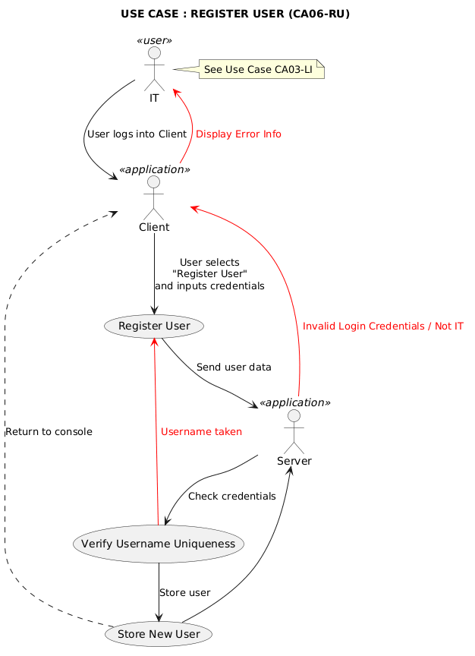
CA07-SMG
@startuml

title "USE CASE : SEND MESSAGE (GROUP) (CA07-SMG)"

note "See Use Case CA03-LI" as LI
note "See Use Case CA01-SM" as SM1
note "See Use Case CA02-CG" as CG

actor User <<user>> as U
actor "Group Members" <<user(s)>> as GM
Client <<application>> as CLI
Server <<application>> as SER

(Send Message) as SM
(Validate Message) as VALID
(Deliver Message to Group) as DELIVER
(Log Message) as LOG

U .> LI
SM .> SM1
DELIVER .> CG

U --> CLI : User logs into Client
CLI --> SM : User selects group chat\nand types message
SM --> SER : Send message data
SER --> VALID : Validate text message
VALID --> DELIVER : Forward to group members
DELIVER --> GM : Deliver message
DELIVER --> LOG : Store message in history
LOG --> SER
LOG .> CLI : Update chatbox / console

' alternate flows
CLI --> U #line:red : <font color=red> Display Error Info
VALID --> CLI #line:red : <font color=red> Invalid / Empty Message
SER --> CLI #line:red : <font color=red> Invalid Login Credentials
DELIVER --> SER #line:red : <font color=red> Not Delivered / Stored

@enduml

ZLInRjim5Dpv5G_kK7bGchH30SCr8iYg841AWX3or8MHQOS0JGeadSH_t_SeMN1G9EWYoxpZyUuUeLiVX0l7WsOigA0bp5fUG9xXOm6yk5j3Kt2UbGKavUDz-p279C-kVwQyAUSpnemDk8LB2QsNa0jwPDS_qhgQWV1GLnymRb0WCdXpym7bUvgNaPANZ8akM4UmW-NoY3-h5K7j2CnAPuyzDFBm99sVZPp4pmTQsR1SAsa20gBljUf4KDOCO8uckNGlKVeVb1UFZ2LScYsgUo_sSZxOPib6QBKLQFqIs6HrjMR9Mcf5YYC4mKAq63dhegusg9lKTlzkStsFKLkuMb5nlA4NwcVaqzyy4j9qHRPnGh4HRVSUbC4pXfICCEAWn4ZnKiikUDZ7dhfd4VuOWPd2gPSU3eC7EZ9kmxDm-9HvH01p2aRhXCUCo9WA2F8jJ283IhopxmNyjkvLk2tLC3Wu39EQeX6z9BVduivgbmIiXtpXmELaJ1buLXwNJepWqNvylvfAwgDBIlrat-0RTDPugoLZNq7e89qXUAVjgv-gQ-6BLaOkdDoYmd9dyV9qLblt2rSmclAz5YSedCFhLvcTlSXD6f_khimBLOTEYaCVJkSxC1Nytm9uWR207DTmx4hezuMItASoTpQS2vVa9bQxPUmMHu-VXBy0

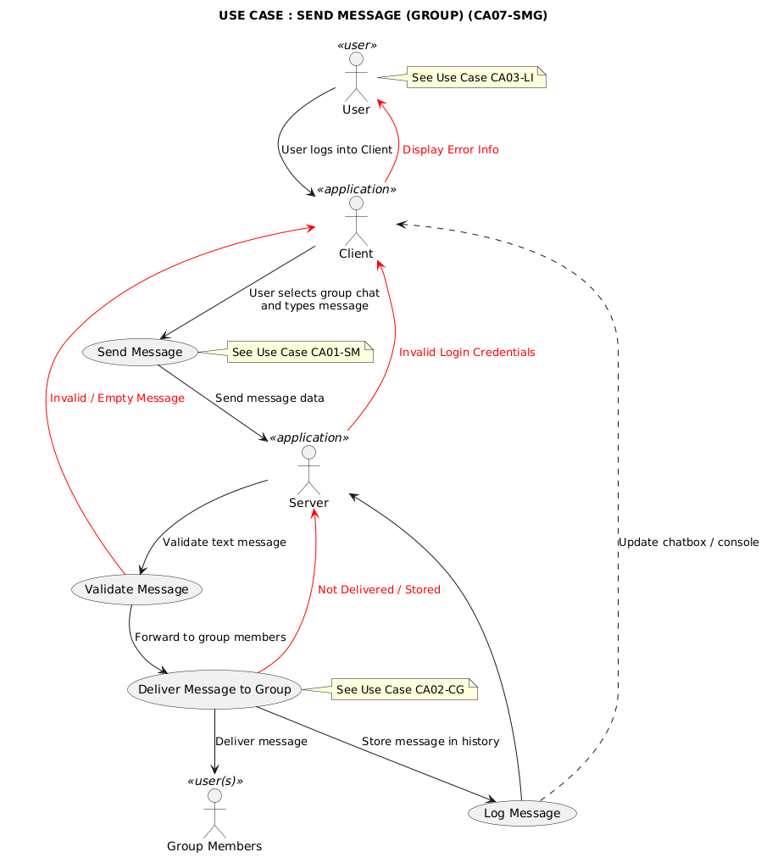
CA08-VCH
@startuml

title "USE CASE : VIEW CHAT HISTORY (CA08-VCH)"

note "See Use Case CA03-LI" as LI

actor User <<user>> as U
Client <<application>> as CLI
Server <<application>> as SER

(View Chat History) as VCH
(Retrieve Stored Messages) as RET
(Display Messages) as DM

U .> LI

U --> CLI : User logs into Client
CLI --> VCH : User opens chat interface
VCH --> SER : Request chat history
SER --> RET : Retrieve stored messages
RET --> DM : Send messages to client
DM --> CLI : Display scrollable\nchat history

' alternate flows
SER --> CLI #line:red : <font color=red> Invalid Login Credentials
CLI --> U #line:red : <font color=red> Display Error Info
RET --> CLI #line:red : <font color=red> No Messages / Retrieval Error

@enduml

XPBVIyCm4CVVxwyuveFpOIhu8cEMZQpGmgRGhXF1bzXTjq1CPf9D_E-zjFk12FgImds-pNrooTW7wSBkNGC45JHXhofJ51DUXhZCqsSKsMI1MLukdeeNx8l9xVrWARAh7e2nWVCb4LQUKCYuJ6xl1hEyXzBZB0UGTR0kOeUZqOu_IH9H1K8hCe6BShlLgfP1MTCnmV-LvFRjBxzecHO0_QMYJnGR6J1JdZjyNKN6Mj0lA3X5UyAIwxJ2ENalr-JRH94ke3zLVglbrqyodGDKU9sqrXKE1aaKuHcqxjgkFIeJB7RU45dCSCjZncx9UAoZ52V9DR8cY3pcM9jp1Ntio8SkjEdC8Q8OORSsSj3tdVxxGH8YZh7fd5CbcJD2rgexBOPdy-CvVUsirl9DqwlvqHakKMesDPBliT7sqvzauWuNMXaQHeaXZXhBjrLRRTq3LnBCpLvgjSAPNIk3WclSNqdjJwEf_jxWQ9SwnoyaDuqz7V7Vve_sT7buSnoPrDrU06EU3h_eRm00

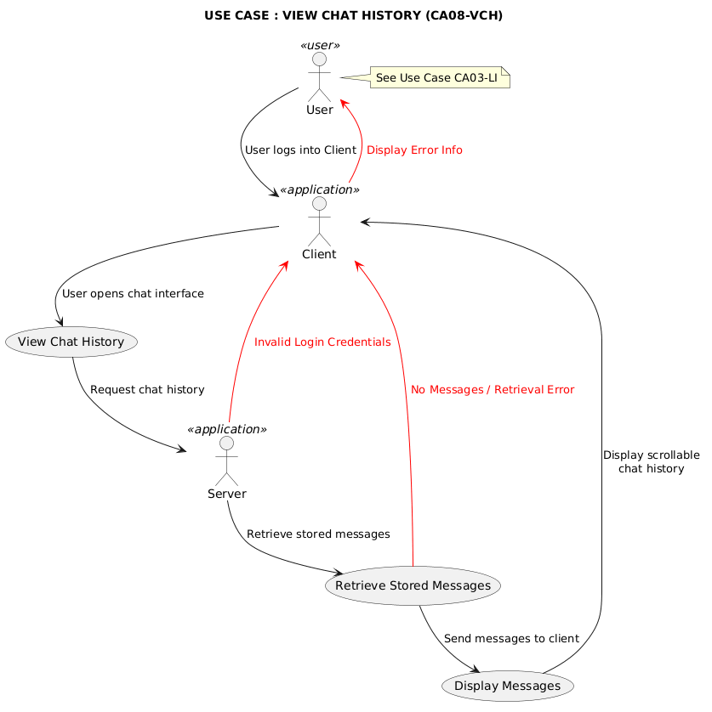

CA09-RCL
@startuml

title "USE CASE : READ CHAT LOGS (CA09-RCL)"

note "See Use Case CA03-LI" as LI

actor IT <<user>> as IT
Client <<application>> as CLI
Server <<application>> as SER

(Read Chat Logs) as RCL
(Request Log Information) as REQ
(Retrieve Log Files) as RET
(Display Chat Logs) as DISP
(Log Access Event) as LOG

IT .> LI

IT --> CLI : User logs into Client
CLI --> RCL : User selects\n"View Chat Logs" function
RCL --> SER : Request log data
SER --> REQ : Specify log requested info
REQ --> RET : Retrieve requested logs
RET --> DISP : Send logs to client
DISP --> CLI : Display requested\nchat logs
DISP --> LOG : Log access request
LOG -> SER

' alternate flows
SER --> CLI #line:red : <font color=red> Invalid Login Credentials / Not IT
RET --> CLI #line:red : <font color=red> Log Not Found / Retrieval Error

@enduml

XLDDQzmm4BtFhnYSGpU7JG8zTTcO6A_J6apRh9sUSX7QSIjGfAqaRyY_xuoy7r0AlHWpxytJUy_oGqmgfEdL0YIJB67nt3TOL_nOuRQfDbX_gGRildtkSL5NTv-MsxgxBW2SJqpkYV0v4jPA7jNTnsNN5gWYTYs0qia7R0TShwT8eIm5Q0UehI6NUAhsUskqIiQx6QnvhQTmeF0lj6-s08ijgHtMlrJ2pl-CrmAm9Pd_dYZcARPkzE4rhyw4vaa8AHWwK6Oy6al7vMQ0nSR4lLNlV-bksluxB8HUQKqnOdDWundYGW0usasPe_BRSbcAVwwD2mbeMGIDInxdk22OSDZiYHF9aaxnnHK_3BrT3Yzmd9mMzo1isUBiya6E6LaSToefa74MRPuOxlUapVYUuJ1JQSScHWz2c8b3rZbMSM69Nn1KM19SzCZD078CFSV8q2NhgRYpq8lJ4YFBdRdS5dEbI3KNUQI307CwW0-eRABW55-iqVgtU4udHrrPusWLsEaArwFd-wEzzU6U9oL_xuEoPYSd68SrpzYgKJRYBNxrIIxTATf_jSIbx3pwYTFVdhfI5fiGV01uu5RuX_a3
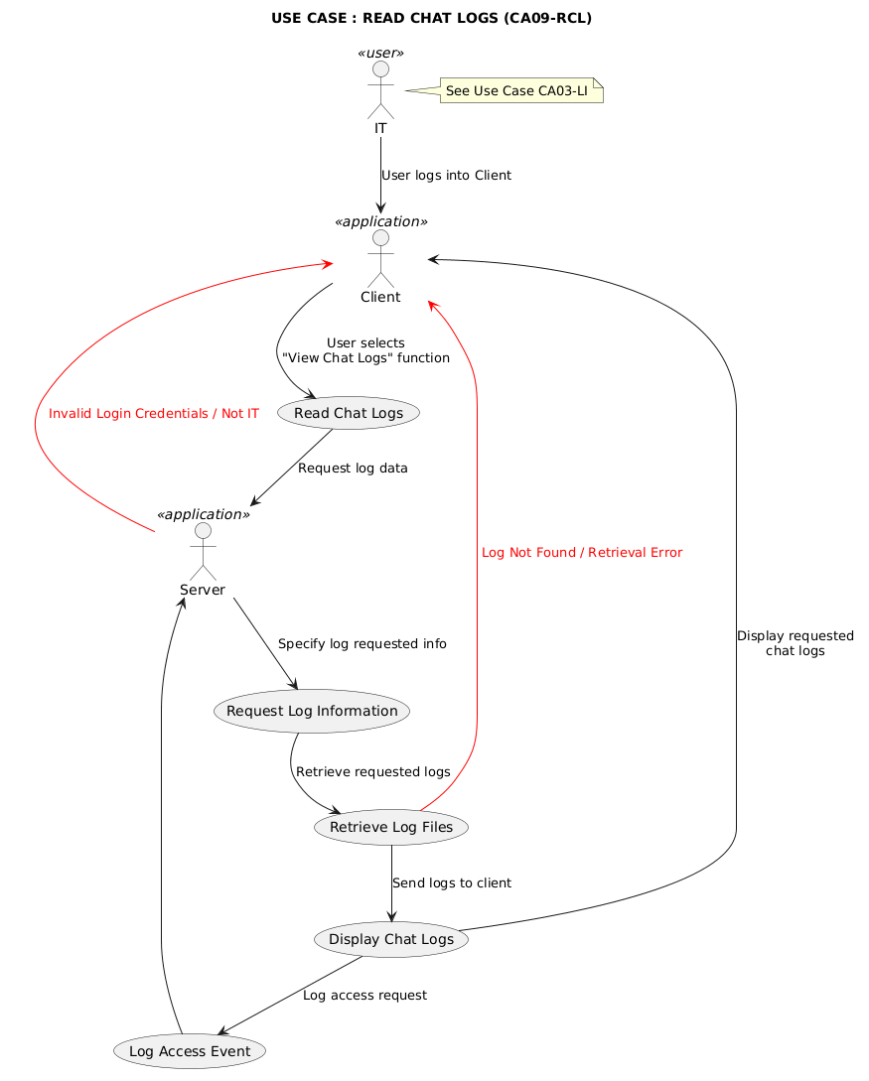

CA10-RM
@startuml

title "USE CASE : RECEIVE MESSAGE (CA10-RM)"

note "See Use Case CA03-LI" as LI
note "See Use Case CA08-VCH" as VCH

actor User <<user>> as U
Client <<application>> as CLI
Server <<application>> as SER

(Receive Message) as RM
(Identify Recipient) as IR
(Forward Message to Client) as FM
(Notify User) as NOTIFY
(Display Message in Chat Window) as DISP
(Log Message) as LOG

U .> LI
DISP .> VCH

SER --> RM : Message received for user
RM --> IR : Identify recipient
IR --> FM : Forward message
FM --> NOTIFY : Trigger notification
NOTIFY --> U : Notify user
U --> CLI : User logs into Client
CLI --> DISP : New message displayed in chat
FM --> CLI : Send to client
FM --> LOG : Save message to history
LOG -> SER

' layout control
SER -[hidden]-> CLI

TLB1IiD04BtFLmozc1uYYXSHAIrfeWkjIj8e8XwMP4qNqcpPR5lwzyxiDXKHBzcmxysRUMzssZjftMxJ0ZZjMeMZiaWncT7d3lCqISLhYikqA6OFAKR9xFegpfVZ4K1d794BfR3i5IQIFxEhctWXHYXxN8X_6BVnQ_BeANG2oCePomIBz_SxEYOJnaf8MgqwHvToksrr9PqsNS0IqYwKtVkIFsYHvW1HhYgbzmgNgkzbeyQCv4k8H4sY-kk8HD1Rxk0XaKEK6NkGjXvAq1aCCtX6HiLFnfVoiFxkwNabidU8vhhVjl9uhjGT9clfy4rtjJbuwbmKBn0jJFDheiNp0q29bnEEYodywsCX5nZ74vgPrZ3esc2gnY-AZBC2WfabScAThTd16eWWah78O6yJn20BfS43uIkhcuOYxTZaAL4ueKmiYNCAmBSk_ItjWkxz-bhJz6Jz71imnXnlZ8hLOMYETKYCh51M5MKrZ1Fq2jNLd7yLX4uOfSMOfBLkVdQqrZsze2CmIYI__WiaSRDpM9dEMTE6E3_MkgQCFaCRW2breOV_3G00
